POWER SUPPLY DESIGN

**AIM**: Design the 5V, 1 amp DC power supply using 230V AC supply

**APPARATUS**:

1. Step down Transformer 230V/12V AC= 1

2. 1N4007 Diode= 8

3. Capacitor 1000uF/50V= 2

4. Capacitor 100uF/25V=2

5. Regulator LM7805 LM7812=1

**Procedure:**

**Step1**: Convert 230V/AC to 12V AC using step down transformer

• Transformer consists of two input terminals and two output terminals

• In transformer one side it contain two terminals and other side it contains two terminals to find out input and output terminals, find the resistance of the both sides using mustimeter. The resistance is high for input terminals and low for output terminals.

• now input terminals are connected to 2 pin plug to 230V AC.

• The output terminals output voltage is 12V AC.

**Step 2**: Convert 12V AC to 12V pulsating DC

• To convert 12V AC to 12V pulsating DC we need a rectifier. Rectifier means which convert AC to pulsating DC

• Here I use bridge rectifier. Bridge rectifier output is full wave form. It contains four diodes D1, D2, D3, and D4.

**What is diode?**

Diode is two terminals device which consists of anode and cathode. It conducts in only one direction.

To convert AC to DC we need to arrange the diodes such that it should convert both positive and negative voltages of AC into positive voltages. This can be done using only full wave rectifier or bridge rectifier.

Rectifier means which converts bi-directional signal into unidirectional signal.

• In this we use bridge rectifier to convert AC to pulsating DC

**Bridge rectifier**:

* The full wave bridge rectifier is designed to convert an AC sine wave to an full wave pulsating DC signal
* The Bridge is normally connected to the secondary terminals of the transformer
* Current will flow from a point with a higher potential to a point of lower potential.

**Why we use 1N4007 Diodes?**

1N400X diodes are used as rectifiers for low frequency having big capacitance at the junction, other diodes have less capacitance value therefore they have quick ON –OFF time.

These 1N4007 diodes are usually slow. To measure the voltage drop across the diode connect a load resistance across the cathode terminal and other terminal of the load is connected to negative terminal of the battery. The drop across the diode is 0.7 volts.

**Filtering:**

The output of the rectifier is pulsating DC. This pulsating DC is converted into pure DC using filter. The filter used in this circuit is LC filter, but practically we won’t use inductor because it is bulky. The value of capacitor depends upon the output voltage and output current. To calculate the value of capacitor the following formulae is used

Q = C x V equation (1)

Q = C x IR

Q = I x RC

Q = I x T equation (2)

Substitute equation (2) in equation (1)

I x T = C x V

C = (I x T) **/** V

Here output voltage is V = 5 DC

Here output current is I = 1.5 amps

Here the input voltage is AC 230V, 50 Hz. The output of the transformer is 5V AC, 50 Hz, here in transformer output of the frequency is 50 Hz because transformer frequency remains constant.

So f = 50 Hz,

T = 1/2 f

= 1 / 2 x 3.14 x 50 Hz

= 3.184713376 x 10

Here output current is I = 1.5 amps,

C = (1.5 x 3.184713376 x 10) / 5

C = 9.554140128 x 10

C = 955.41 x 10

C = 955 uF

The value of capacitor is 955 uF at this value of capacitor are not available so that we have to select the value nearer to it so we use C =1000 uF.

If V = 5V DC and f =100 Hz, I=1.5 then C = 477 uF.

If V = 7V DC and f = 100 Hz, I = 1.5 then C = 330 uF.

**Regulator:**

The purpose of regulator is to maintain constant voltage. For positive voltage output use LM78XX, XX indicates value of output voltage and 78 indicates positive output. For negative voltage output use LM79XX, 79 indicate negative voltage and XX indicates value of output. To get positive 5V regulated output use LM7805.

To get negative 5V regulated output use LM7905.

A Transformer is a static apparatus, with no moving parts, which transforms electrical power from one circuit to another with changes in voltage and current and no change in frequency. A Step down Transformer is a type of transformer, which converts a high voltage at the primary side to a low voltage at the secondary side.

The power in a transformer is rated in Volt – Amps VA (or Kilo Volt – Amps kVA for larger transformers).

In our project we are using 230V to 12V step down transformer, current rating of our transformer is 1 amp.

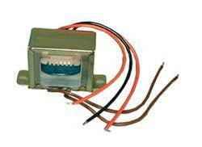

**Fig.** Step down transformer

**4.6.2 1N4007 DIODE**

**Why we use 1N4007 Diodes?**

1N400X diodes are used as rectifiers for low frequency having big capacitance at the junction, other diodes have less capacitance value therefore they have quick ON –OFF time. These 1N4007 diodes are usually slow. To measure the voltage drop across the diode connect a load resistance across the cathode terminal and other terminal of the load is connected to negative terminal of the battery. Then the drop across the diode is 0.7 volts.

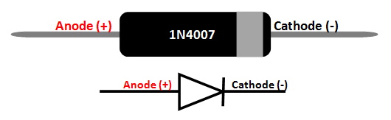

**Fig.** 1N4007 Diode

**4.6.3 Voltage Regulator:**

The purpose of regulator is to maintain constant voltage. For positive voltage output use LM78XX, XX indicates value of output voltage and 78 indicates positive output. For negative voltage output use LM79XX, 79 indicate negative voltage and XX indicates value of output. To get positive 5V regulated output use LM7805.To get negative 5V regulated output use LM7905. To get positive 12V regulated output use LM7812

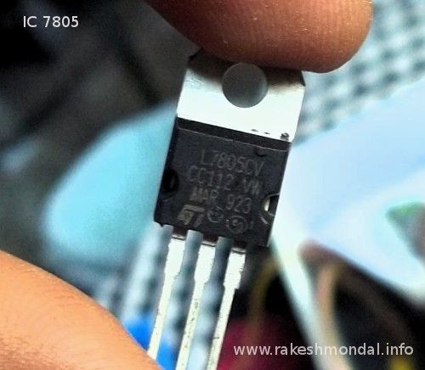

**Fig.** Voltage Regulator

**4.6.4 CAPACITORS**

When there is a potential difference (voltage) across the conductors, a static electric field develops across the dielectric, causing positive charge to collect on one plate and negative charge on the other plate. Energy is stored in the electrostatic field. An ideal capacitor is characterized by a single constant value, capacitance, measured in farads. This is the ratio of the electric charge on each conductor to the potential difference between them.

The simplest capacitor consists of two parallel conductive plates separated by a dielectric with permittivity ε (such as air). The model may also be used to make qualitative predictions for other device geometries. The plates are considered to extend uniformly over an area A and a charge density ±ρ = ±Q/A exists on their surface. Assuming that the width of the plates is much greater than their separation d, the electric field near the center of the device will be uniform with the magnitude E = ρ/ε. The voltage is defined as the line integral of the electric field between the plates. Solving this for C = Q/V reveals that capacitance increases with area and decreases with separation

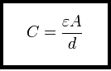

The capacitance is therefore greatest in devices made from materials with a high permittivity, large plate area, and small distance between plates.

We see that the maximum energy is a function of dielectric volume, permittivity, and dielectric strength per distance. So increasing the plate area while decreasing the separation between the plates while maintaining the same volume has no change on the amount of energy the capacitor can store. Care must be taken when increasing the plate separation so that the above assumption of the distance between plates being much smaller than the area of the plates is still valid for these equations to be accurate.

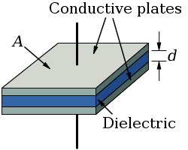

**Fig**. of parallel plates of capacitor

Here we use different capacitors ranging are 1000 micro farad, 100 micro farad for filtering and smoothing purpose power supply.

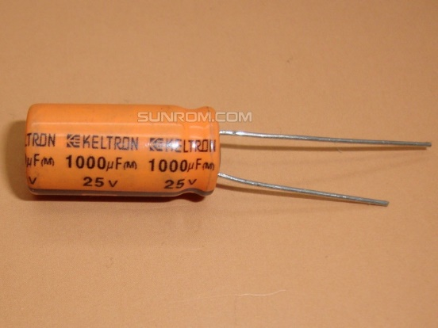 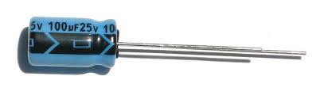

**Fig.** Capacitor